

**MEMORANDUM OF UNDERSTANDING**

This is a document validating an agreement between **MR. OGABOR JOHN AND MRS BODE THOMAS ROBINSON** for the collaborative of 20% interest over a sum of **FIVE MILLION NAIRA ONLY (N5,000,000) paid on the 12th of May, 2020.**

There is a binding agreement to pay the initial capital invested, alongside the interest, **SIX MILLION NAIRA ONLY (N6,000,000) on the 12th of June, 2020** by **MR. OGABOR JOHN TO MRS BODE THOMAS ROBINSON.**

Attached with this document is an evidence of payment by **MRS BODE THOMAS ROBINSON.**

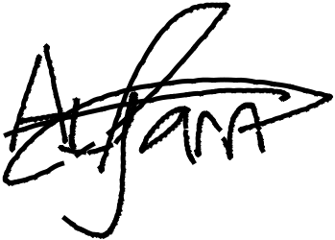

_________________________

_~~__~~_____~~___~~_~~_~~___________



**MRS BODE THOMAS ROBINSON**

**MR. OGABOR JOHN**

***(CEO, JOHN INVESTMENTS)***